Shanice Tricia Skeete

464 Southern Main Road,

La Romaine.

Phone: 372-9595

shanicetskeete@gmail.com

January 10th 2016

Dear Sir/ Madam,

I would like to express my deepest interest in Optical Assistant position advertised within your organization. I am a dedicated person who is interested imparting and gaining new experience in the work field and I believe that if given a chance with your establishment I can be of great asset.

I am twenty (20) years old and attended La Romaine High School where I obtained (4) subjects. I did **C.E.R.T. COURSE CERTIFICATE** and also **RED CROSS COURSE CERTIFICATE.** During my junior years I attended several sport camps during the vacation holiday. I also did a computer course at MODERN SCHOOL OS BUSINESS.

If you allow me the opportunity of employment with your organization, I would bring a focus on quality and dedication to help with the development of your organization. I await your response with hopeful anticipation.

Yours Respectively

___________________

(Miss) Shanice Tricia Skeete

**OBJECTIVE:** To gain experience and gain knowledge in order to enhance my skills and training employed with an organization that allows me to utilize my work.

**EDUCATION:**

**Bien Venue Pres. School (2000-2007)**

**La Romaine Secondary School**

**CXC O’Levels (2007-2012):**

* Mathematics 4 (Awaiting results from January CXC)
* F&N 3
* English A 3
* POB 4
* Social Studies 3
* POA 4
* Dance 3

**WORK EXPERIENCE:**

**CASHER AT JTA SUPERMARKET**

**CROSS CROSSING SAN FERNANDO**

**FLAME INDUSTRIES: SSL**

**SUTTON STREET SAN FERNANDO**

* EMBROIDERY

TRINIDAD & TOBAGO RED CROSS SOCIETY

STANDARD FIRST AID

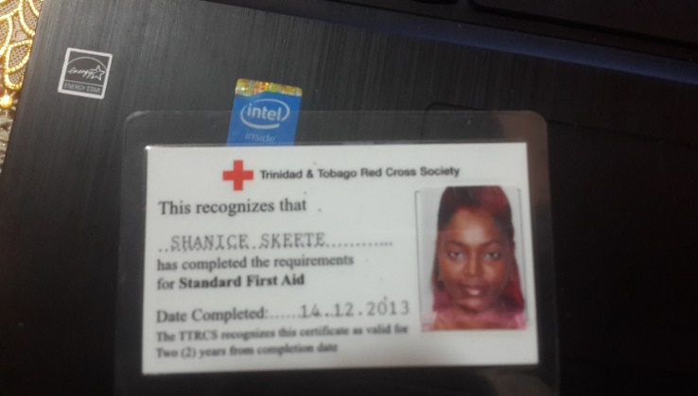

CERTIFICATE OF ACHIEVEMENT

RBC YOUNG LEADERS

CERTIFICATE OF COMPLETION

Five days’ Workshop on Community Emergency Response Term (C.E.R.T)

(22nd – 26th July, 2013)

REPUBLIC OF TRINIDAD AND TOBAGO

CERTIFICATE OF CHARACTER

**REFERENCES:**

**ROLAND HALL** – VICE CHAIRMAN/ COUNCILLOR

PALMISTE/HERMITAGE

PENAL/DEBE REGIONAL CORPORATION

Tel: 1-868-647-6302/2685

Fax: 1-868-647-0685

Email: [pdrc@pdrctt.com](mailto:pdrc@pdrctt.com)

Cell: 765-6654

Email: [rolleh51@live.com](mailto:rolleh51@live.com)

**REV. NEVILLE RAMSEY** – MINISTER OF ST. BENEDICTS SPIRITUAL BAPTIST CHURCH, CHARLES STREET LA ROMAINE.

Tell: 396-3853/763-1256.